Lab 2

Siyuan Chen Benjamin Darçot

TASK6 A

The model fit quite well the training model, because at the last iteration, the loss value is really close to 0. But the validation dataset is not well fitted and it is worse through the iterations, this shows a clear overfitting.

TASK6 B

Reducing the n_base reduces the overfitting but does not cancel it. It is normal that it reduces it because there are less neuron and it will fit less the noise of the training dataset.

As expected the dropout layer reduces also the overfitting, however it doesn't cancel it either. This reduce is expected because the drop out layer randomly delete some neurons in the dense layer, making the learning power of the network weaker and therefore it cannot fit too well the training dataset.

TASK6 C

With the higher learning rate, it will increase the train accuracy, but also can lead to overfitting.

TASK6 D

Not too much significant differences

TASK6 E

For Adam, accuracy_train = 0.83 accuracy_var = 0.8

For SGD, accuracy_train = 0.83 accuracy_var = 0.848

For RMSprop, accuracy_train = 0.825 accuracy_var = 0.836

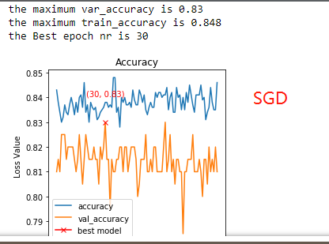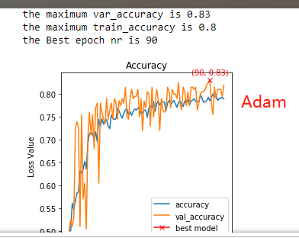

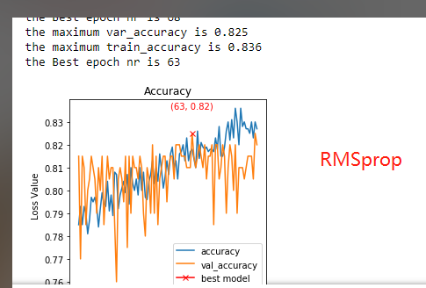

TASK6 F

The accuracy with ‘hinge’ is lower than ‘BSE’ for this model.

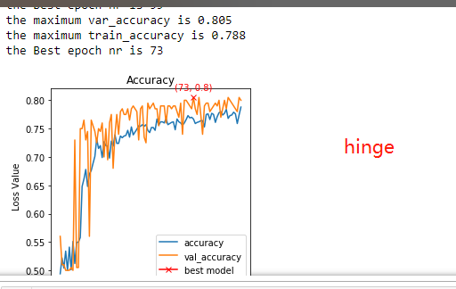

TASK7 B

We compare the learning rate of 1e-3 1e-4 1e-5. 1e-4 is the proper learning rate with the highest accuracy in the verification group

TASK7 C

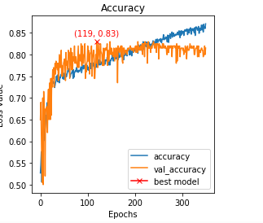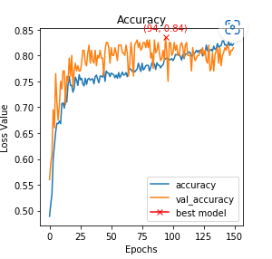

The classification accuracy over validation of VGG16 model is higher than the accuracy of AlexNet model(0.84>0.83).

VGG16 adapts the same block structure, the convolution kernels of the same size are reused many times to extract more complex and expressive features.

TASK7 D

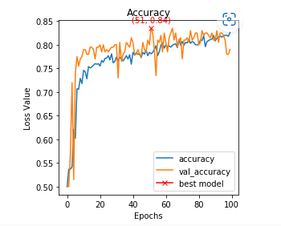

Not change the model performance very much.

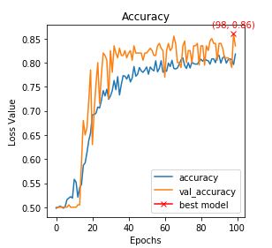

But with dropout. The model performance is improved.

TASK7 E

The difference between LeNet, AlexNet and VGG16.

LeNet

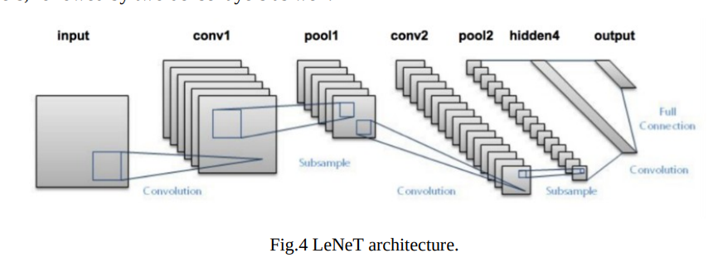

AlexNet

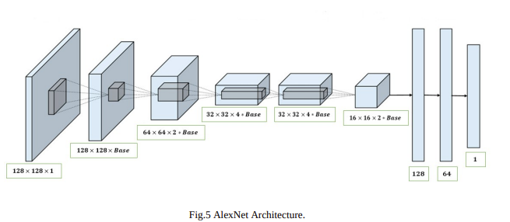

VGG16

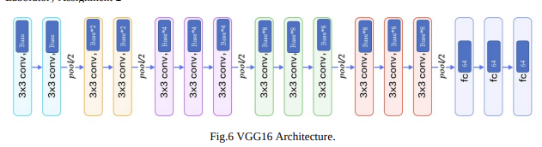

Compared with LeNet, AlexNet has a deeper network structure with a total of 8 layers, including 5 layers of convolution and 3 layers of full connection.

While Vgg strictly uses 3*3 small size convolution and pooling layer to construct deep CNN, and achieves good results. Small convolution reduces parameters and facilitates stacking convolutional layers to increase depth (deepens the network and reduces convolution).

I think VGG16 can yields more accurate classification results. Because it can achieve the most nonlinear function under the situation of same parameters.

To evaluate the model performance. we should focus on the loss value or accuracy rate on the verification dataset. Adapting the dropout strategy can prevent the model training from overfitting.

TASK9

The skin image set classified more accurately. Because the accuracy rate in test dataset is higher (0.86>0.85).

To make sure the results are reliable, we need to evaluate the trained model.

By using model.evaluate(x_test,y_test)

print(‘test loss: ’,result[0])

print(‘test acc: ’,result[1]]

TASK10

For multi-classification problem, I use the one-hot code to set the label. And change the last output dense layer with the number of labels and the activation function of ‘softmax’.

Also modify the loss function with tf.keras.losses.CategoricalCrossentropy()

The result for LeNeT is

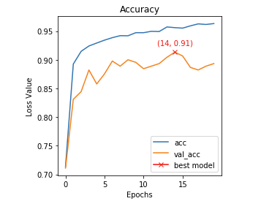

And the result for AlexNet is

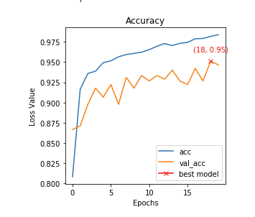

The performance of AlexNet is better than LeNet.